**Tutorial 4: Conditional Rendering**

Conditional rendering is a term to describe the ability to render different user interface (UI) markup if a condition is true or false.

The tutorial will be covering **v-if**, **v-else**, **v-show** and **v-hide**.

Make sure **Tutorial 3** is complete to be able to move on to this tutorial or clone the [vue3-firebase-course](https://github.com/younggrasshopperza/vue3-firebase-course) repository and go to branch called **Tutorial-3**.

In the **index.html** file, make sure the body tag has the below code:

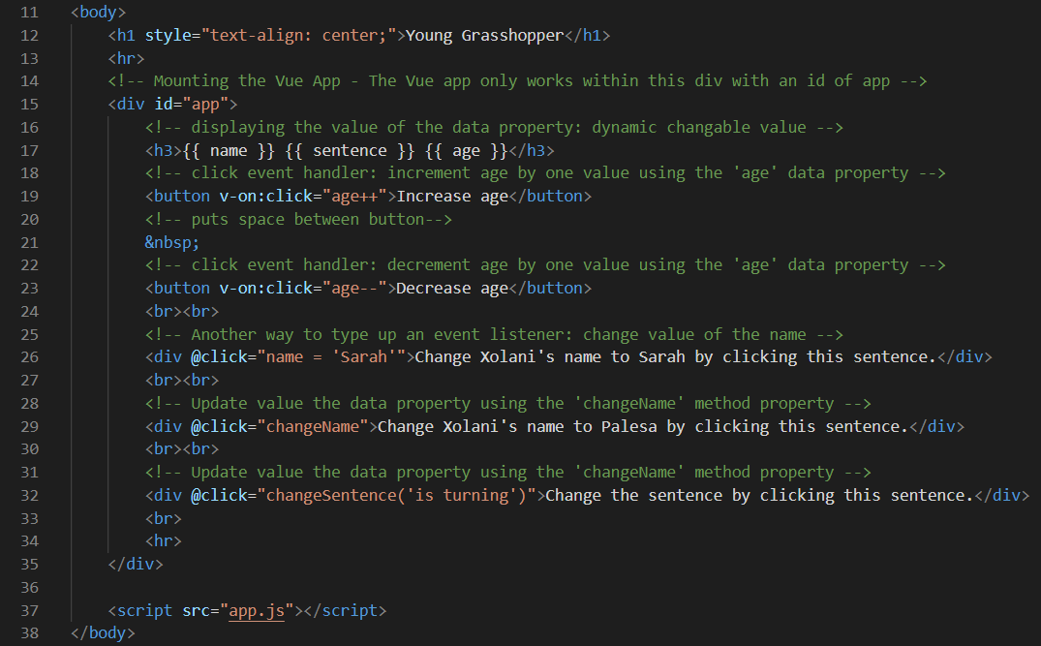

Remove **line 18 to 34** as this was for demonstration purposes for the previous tutorial.

In the **app.js** file, make sure the code looks like the below:

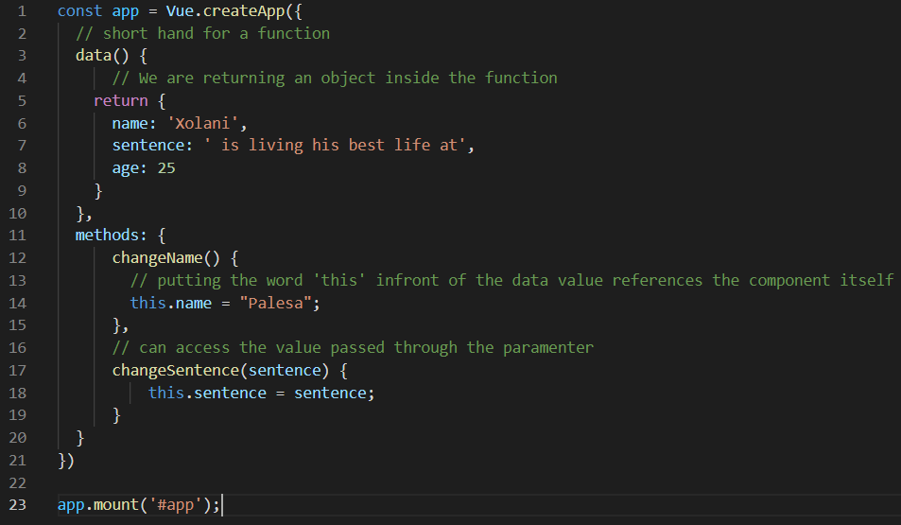

Remove **line 12 to 19** as this was for demonstration purposes for the previous tutorial.

**Step 1:** Continuing from Tutorial 3, in the **index.html** file, create a **div** tag wrapped around a **h3** tag and provide a conditional **if statement** inside the **div** and set the value to **true**. Create **div** tag with a wrapped around a **h3** tag and provide a conditional **if statement** inside the **div** and set the value to **false**.

The **div** set to **true** will be **outputted** whilst the div set to **false** will not be **outputted**. Change the value to true to see the value.

**v-if** is used to completely remove the tag that is assigned to it.

Look at the example below (**Line 20 to 27**):

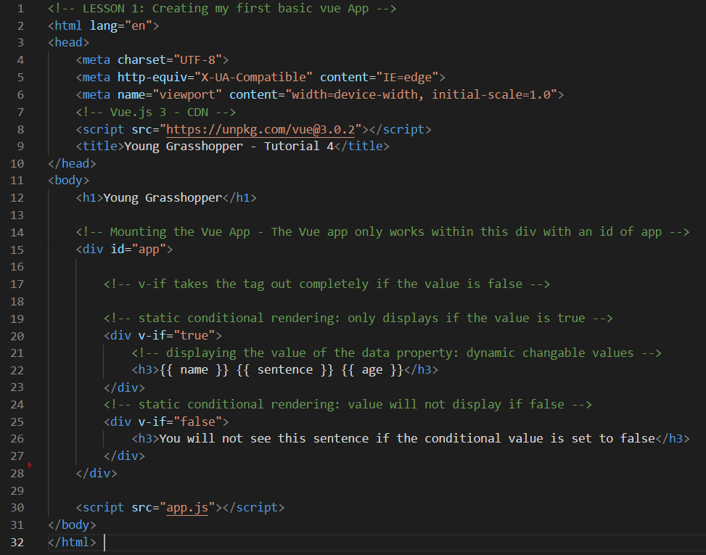

**Output:**

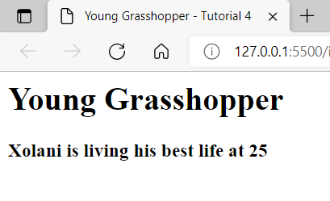

**Step 2:** In the **app.js** file, create a **data property** that is assigned to **true**. Create a function that changes the **data property** to the opposite **Boolean** when the method is called.

Look at the example below (**Line 13 to 16**):

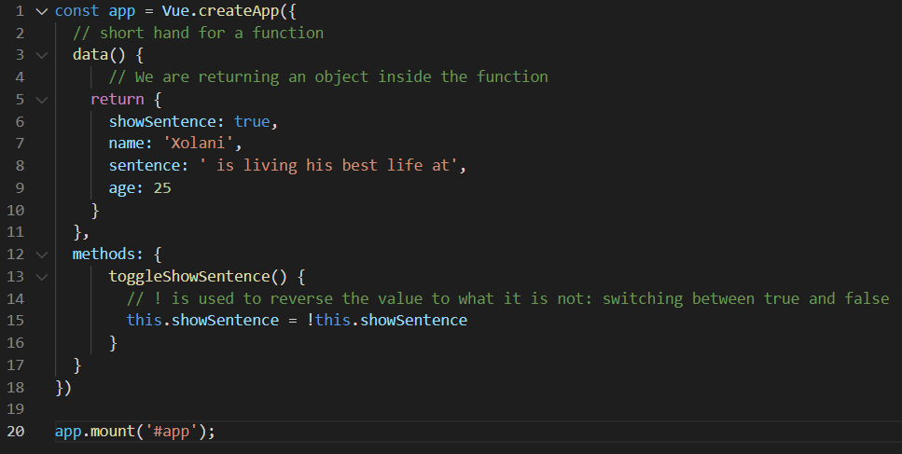

In the **index.html** file, create a **div** tag wrapped around a **h3** tag and provide a conditional **if statement** inside the **div** and set the value to the **data property** created in the **app.js** file.

Create a **button** tag that has a **click event** with the **method** created in the **app.js** file, inside the **button** tag include a **span** that has **if statement** with the **data property** created and another **span** that has an **else statement**.

Look at the example below (**Line 30 to 40**):

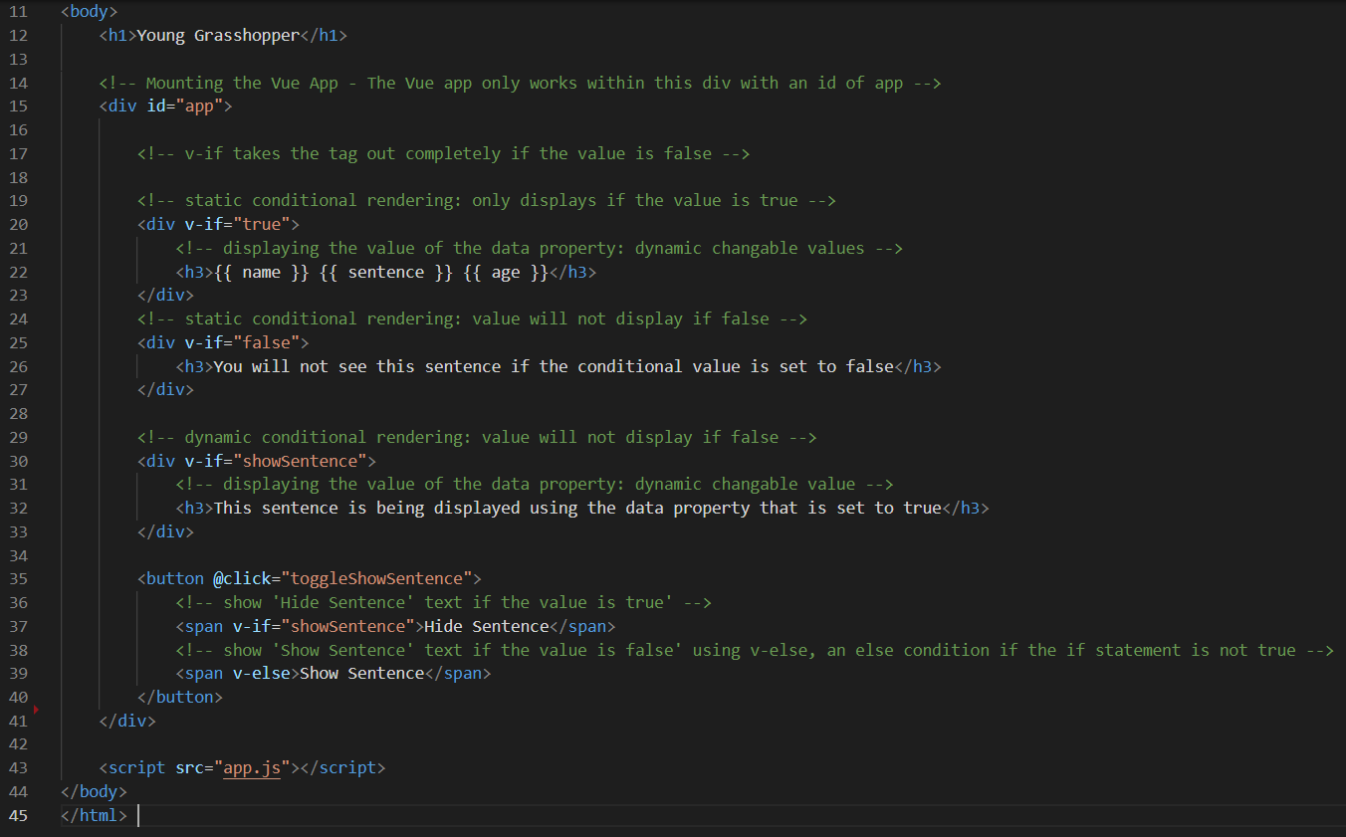

**Output:**

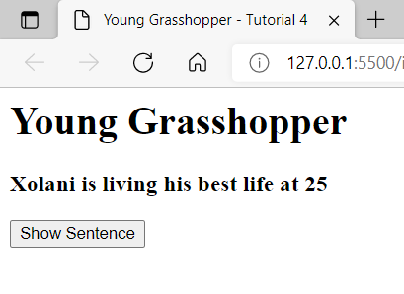

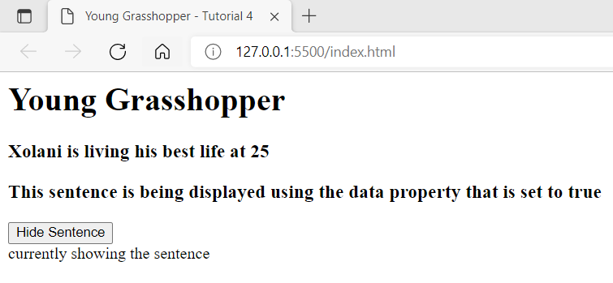

**Step 3:** Create a **div tag** that uses a **v-show** property to **show** the tag that is assigned to it rather than remove the **tag** when the value is set to **true**. The **CSS** styling is set to **display:none** when the value is **false**.

Look at the example below (**Line 44**):

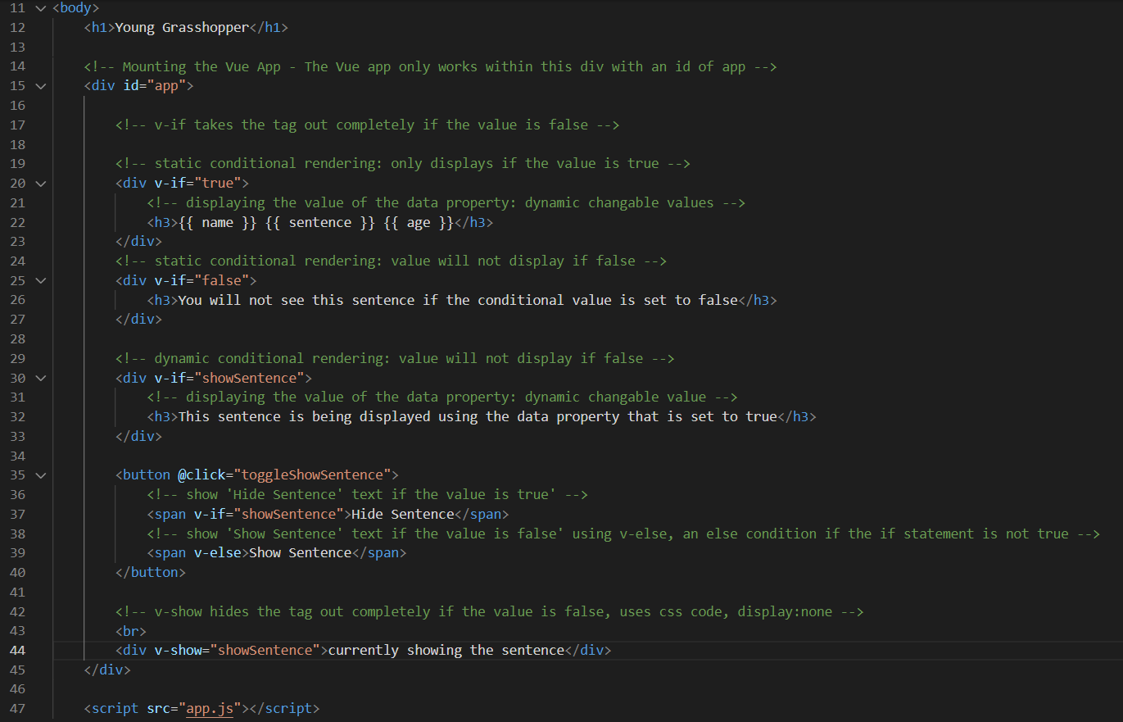

**Output:**

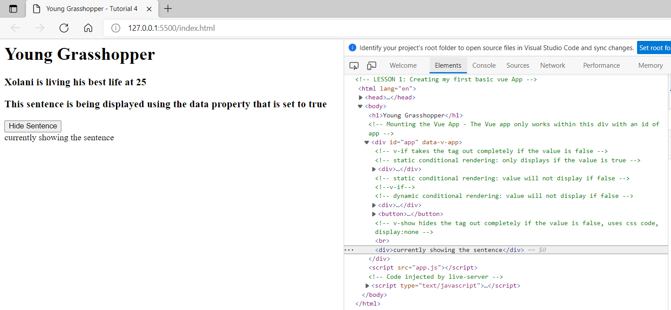

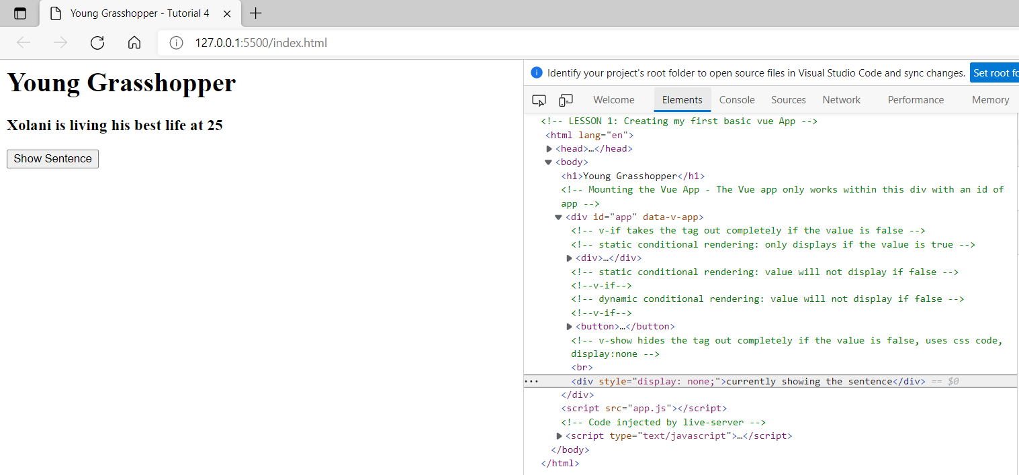

**Extra: v-hide** property is used to **hide** the **tag** that is assigned to it when the value is set to **true**. The **CSS** styling is set to **display: none** when the value is **true**.

Additional Resources can be found in the [vuejs.org](https://v3.vuejs.org/) website under the [conditionals and loop](https://v3.vuejs.org/guide/introduction.html#conditionals-and-loops) section.

**You can view the code snippets from the** [**vue3-firebase-course**](https://github.com/younggrasshopperza/vue3-firebase-course) **repository under the Tutorial-4 branch.**